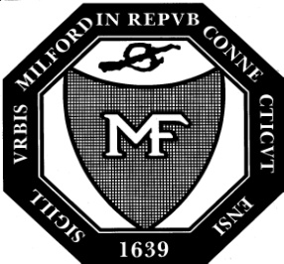

City of Milford, Connecticut

Founded 1639

Office of the Pension & Retirement Board
70 West River Street, Milford, CT 06460

(203) 783-3224

(203) 783-3224

TO: Karen Fortunati
City Clerk

FROM: Tania R. Barnes, SHRM-SCP
Human Resources Director

DATE: November 21, 2023

SUBJECT: Pension and Retirement Board Meeting Dates for 2024

The Pension and Retirement Board meets on the third Thursday of each month. Our meetings have been scheduled for 2024 as follows:

January 18, 2024 July 18, 2024
February 15, 2024 August 15, 2024*
March 21, 2024 September 19, 2024
April 18, 2024 October 17, 2024
May 16, 2024 November 21, 2024
June 20, 2024 December 19, 2024*

While all meetings are scheduled for Conference Room C, second floor, Parson’s Government Building, 6:00 PM due to the pandemic they are being held virtually via Zoom until further notice.

cc: Community Development

Note: *The August and December meetings are subject to cancellation.

