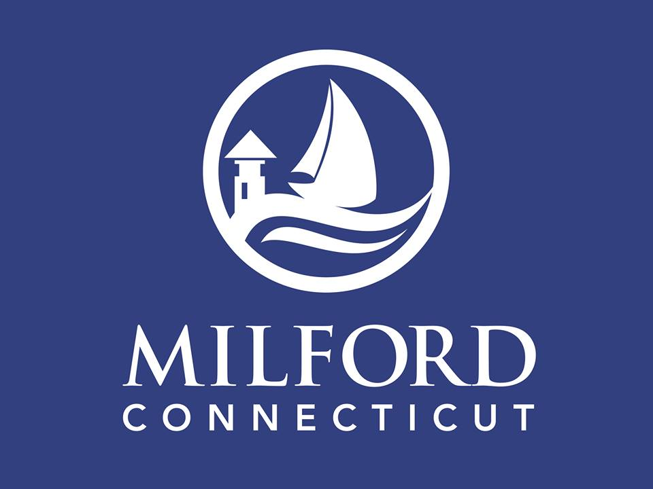

Request for Interest

###### City of Milford

**Waterfront Restaurant Development Opportunity**

**24 Helwig Street**

**Issued by**

**City of Milford**

Date:

December 14, 2018

Request for Interest

###### City of Milford

###### Waterfront Restaurant Development Opportunity

**24 Helwig Street**

**CONTENTS**

Legal Notice (Invitation to Submit Interest)

Project Overview

Project Objective

Submission Requirements and Schedule

Limitations

**ATTACHMENTS**

Appendix A

Market Analysis, Realty Concepts, Inc.

Appendix B

Transit-Oriented Study, BL Companies

**LEGAL NOTICE**

**City of Milford**

**Request for Interest**

**24 Helwig Street**

The City of Milford (collectively known as “Owner”) is contemplating entering into a lease with interested and qualified parties to inhabit the development of a waterfront restaurant on City owned property located dockside at Lisman Landing. The City would be responsible for the construction of the development with input from a potential partner. The location currently houses the US Coast Guard Flotilla and is part of a larger parcel of property that includes an active public marina, parking lot and and marine related activity.

Respondents are asked to complete the accompanying form and return it to the Community Development Office, 70 West River Street, Milford, CT by 4:00 p.m. on Monday, February 11, 2018.

The documents comprising the Request for Interest may be obtained on the Purchasing Department website, www.milford-ct.gov, under “Current Bids”. Each respondent is responsible for checking the City’s website to determine if the City has issued any addenda and/or additional supplemental documents, needed to complete its proposal in accordance with the RFI as modified by the addenda. Also, some large supplemental documents will only be available directly from the Purchasing Agent, on request. For additional information and to arrange a site visit contact Julie Nash, Community Development Director, 70 West River Street, Milford CT 06460, 203-783-3230, [jnash@ci.milford.ct.us](mailto:jnash@ci.milford.ct.us).

The City of Milford reserves the right to reject any and all responses to this RFI, to advertise for new RFI responses, or to accept any RFI response deemed to be in the best interest of the City. A response to this RFI should not be construed as a contract nor indicate a commitment of any kind. The RFI does not commit the City to pay for the costs incurred in the submission of a response to this RFI or for any costs incurred prior to the execution of a final contract.

Questions regarding this Request for Interest should be directed to Fred Bialka, by e-mail at fbialka@ci.milford.ct.us.

Date: December 14, 2019

City of Milford, Connecticut

Julie Nash, Community Development Director

#### PROJECT OVERVIEW

#### 

#### THE OPPORTUNITY

The City of Milford is seeking qualified partner(s) for a key waterfront development site located at 24 Helwig Street otherwise known as Lisman Landing. This site is approximately 1 acre and currently occupied by a 1900+ sq. ft. building housing the US Coast Guard Flotilla. Adjacent to the development site sits a marine dock office, maintenance shop, public transient dock as well as an ice cream parlor. Alongside the subject site sits a visitor parking lot with approximately 90 spaces in season with 60 in the off season. These spaces are available for patrons. A potential partner would coordinate with the City in the planning of the development, and eventually lease this site to create a top-quality restaurant with dockside dining.

#### Community Profile

Milford is a coastal City committed to maintaining its New England charm. With a population of 52,000 + residents and growing, it is an outstanding location for businesses and residents as it is in the center of the state nestled between Hartford and Stamford, New York and Boston. It is at the confluence of major highways including I-95 and the Merritt Parkway. Due to its proximity to New Haven and world-renowned universities such as Yale University, Sacred Heart University and University of New Haven it affords access to a labor force of over 400,000 people in the region that can commute to Milford without encountering the traffic congestion of the larger urban areas.

Significant demographic and economic characteristics of Milford include:

* 69.4% of the housing stock is single family and 77.2% is owner occupied
* A median income of $91,600 well above the state median income of $55,277.
* An unemployment rate less than the State and national average.
* The top three employment industries are retail, manufacturing and healthcare.
* Milford is home to more than 15,000+ employees over the age 25 holding advanced degrees, ensuring exceptional access to a highly educated workforce.
* Major employers are Schick-Wilkinson Sword, Milford Hospital and Subway World Headquarters.
* A 27% increase in construction permits including commercial, residential and industrial from 2016.

Source: CERC Town Profile (2017), American Community Survey, City of Milford

#### Image result for downtown milfrod ct

#### DOWNTOWN MILFORD

The development site is located in Downtown Milford. In this area, a New England town green is the focus of a vibrant mix of civic, cultural, residential and commercial activity. Civic issues include the city hall, post office, chamber of commerce, and four churches. Commercial activity includes a pharmacy, restaurants, retail, several banks, and professional services.

The public library, Milford Arts Center, Milford Historical Society, Lauralton Hall and public outdoor recreation center are all located in the heart of downtown. The downtown also functions as a major transportation hub with the adjacent Lisman Landing Public Marina, Metro North train station and a comprehensive transit system.

The Milford Harbor is filled with water influenced recreational activity and nearby upland commerce, with visitors from City Island, NY, Mystic, and from many points fromLong Island Sound.  Milford Harbor is home to a number private marinas, the Milford Yacht Club, Port Milford, Spencer’s Marina & Milford Boat Works, all demand generators.  The popular public boat ramps issues 500+/- permits per year.  We estimate about 1,200 boats visits per year that dock at Milford Harbor generating approximately 2,500-3,500 visitors to downtown Milford each summer that stimulate our local economy.  The average boater stay is 2 nights.  The public marinas have maintained a yearlong waitlist for holiday and major festivals for 15 years.  As one of the only public marinas in the area, there is not much competition for Milford Harbor. In comparison to private marinas fees, it is well below market while offering comparable quality boating facilities.

The subject site at Lisman Landing Marina is located just steps from beautiful historic downtown Milford. The marina employs 1 full time and 11 seasonal employees.  It is an all transient marina with 38 slips which can accommodate vessels up to 65 feet. The minimum dredge depth is 7 feet at mean low water. Available amenities include trained dock staff to assist in tie-up, complimentary morning coffee and newspaper, free pump out with an overnight stay, 30 amp and 50 amp electrical service, ice and water, a laundromat, handicap accessible shower and restroom facilities, barbecue/picnic area, car rental, bicycle rental nearby, tennis courts and concierge service. Many restaurants and shops are within walking distance. Reservations are a must for weekends during the season.

The marina is a beautifully landscaped, welcoming place with tables and chairs, bike racks and an attentive staff. Tourists are varied with 60% out of state, 20% outside of Milford and about 20% from Milford. The location has become so attractive that the City now holds a number of its major events at the marina each year. This is the fourth year for our annual fireworks event, which now draws over 25,000 people downtown and countless others to the harbor. These events as well as many others keep the marina booked well in advance.

The Downtown Milford Business Association (DMBA), a membership organization of local businesses, provides year round promotion and events for downtown.

#### COMMUTER RAIL SERVICE

Currently, Metro North provides services to the Milford station via the [New Haven Line](https://en.wikipedia.org/wiki/New_Haven_Line). It is 63.2 miles from [Grand Central Terminal](https://en.wikipedia.org/wiki/Grand_Central_Terminal) and the average travel time from Grand Central is one hour, 32 minutes. The station consists of two separate stations on either side of the tracks. There are 89 departures per weekday and 73 total weekend departures.

#### PROJECT OBJECTIVE

To partner through a long term lease with an experienced, talented and qualified restaurateur to achieve a viable dockside dining concept at the subject site. If you can satisfy the following conditions, you are invited to submit for consideration. You must have:

1. owned or have developed a successful upper to midscale table service restaurant(s) or have partners with such experience;

2. have the ability to enter into a contract with the City of Milford and satisfy its insurance and performance surety requirements;

All qualified submissions will meet with the City staff to further discuss qualifications. A formal Request for Proposal may follow to qualified individuals.

**RFI SUBMISSION REQUIREMENTS AND SCHEDULE**

Each Statement of Interest should be organized in the following order:

**1. Title page**. The title page should show the respondent’s name, RFI title, and date of submittal.

**2. Letter of introduction**. Within one page, the respondent should include the name, address, and statement of whether the respondent is an individual, partnership, corporation, joint venture, special-purpose entity, or other entity. The letter should also provide the name of the person(s) authorized to make representations for the respondent and his or her phone number.

**3. Relevant project experience**. Provide previous experience to include restaurant experience, restaurant development, restaurant construction and geographic locations of those restaurants. Also, describe the role the respondent performed in the venture. Emphasis should be placed on experience and involvement in relevant projects.

**4. References.** Provide references (name, title, entity, telephone number, email and contractual relationship to respondent) that can be contacted at this time with respect to current and past project experience.

Please provide one (1) electronic copy and (1) hard copy, as outlined above and submit to:

Julie Nash

Community Development Director

City of Milford

70 West River Street

Milford, CT 06460

jnash@ci.milford.ct.us

The submittal package must be received at the above office by 4:00 PM on Monday, February 11, 2019.

The evaluation of submittals in response to this RFI does not constitute any form of commitment from the City. It is anticipated that each submittal will be evaluated based on the information submitted plus any other independent information developed by the City. The City reserves the right to request clarification or additional information from a respondent if necessary.

#### LIMITATIONS

The City of Milford reserves the right to reject any and all responses to this RFI, to advertise for new RFI responses, or to accept any RFI response deemed to be in the best interest of the City. A response to this RFI should not be construed as a contract nor indicate a commitment of any kind. The RFI does not commit the City to pay for the costs incurred in the submission of a response to this RFI or for any costs incurred.