Animal Commission Agenda
May 10, 2020 10:00 AM

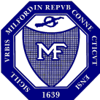
Milford Connecticut
Founded 1639
Milford Animal Control 664 East Broadway Milford CT 06460 (203) 783-3279
________________________________________________________________________

Roll Call

Minutes

Wardens report

Department report

Commission report

Correspondence:

New Business:

Old Business:

