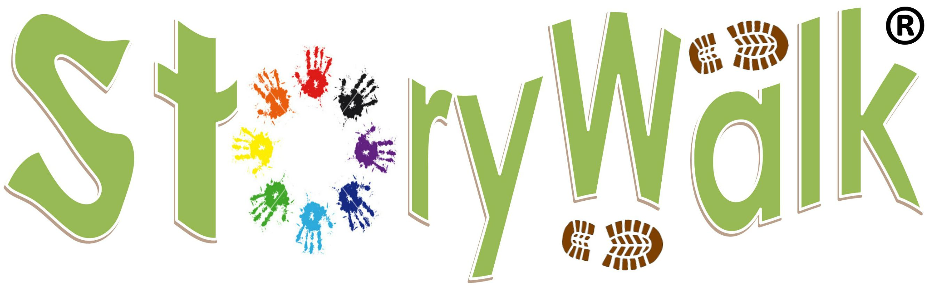
CharitableDonationForm

Milford StoryWalk

Name:,
Phone:,

Address:

City: State: Zip:,

Email:
Enclosed is my tax deductible gift of: $ _

 I prefer to donate anonymously. Please do not list me as a sponsor on the web-site
 I approve the usage of my company’s name & logo on the list of sponsors to this project.
(This includes the Web-site, Facebook page and any other material that lists sponsors)
 Please send me a tax-deductible receipt for this donation
- The Friends of the Library is a Section 501(c)3 nonprofit and your gift may qualify as a charitable deduction for federal income tax purposes

www.milfordstorywalk.org facebook.com/milfordstorywalk

