Veterans, Ceremony and Parade Commission Regular Meeting
February 2023 Meeting Minutes

Opening: The Veterans, Ceremony and Parade Commission held their Regular Meeting on Thursday January February 9, 2023 in the Fowler Memorial Building, 45 New Haven Avenue, Tom Jackson called the meeting to order at 7:05pm and asked those present to stand for the Pledge of Allegiance.

Roll Call:
Members Present:
Tom Jackson
Frank Rodriquez
Jack Jansen

Guests:
Bill Kates
Cathy Gorman – Recording Secy

Agenda
Agenda provided by Tom

A quorum was not present for tonight’s meeting

Moment of silence for Niles

Consideration of Minutes: Tom reviewed January minutes

No quorum to accept minutes, hopefully January meetings will be approved in March minutes.

New Business:

- Asked Justin for more citizens in the group
- Asking for volunteers
- Flags: ordered 40 gross
- Sikorsky fly-over, as an exercise. Should we check that out.
- Send Memorial Day invitations out early April
- Further discussion on Korean monument, needs tree removal, possibly contact Jim Broach or Steve Johnson.
- Bill will replace flags on monuments on the green
- Check website, send screen shot of members
- Call Karen about DAR vs DAV
- Review mission statement: DAR, Milford Volunteers, drum corps, VVA Legion, Viet Nam vets
- Check out Catholic War Vets
- Memorial Day Wreath Laying: 5/28 -10an – need (5) wreaths – were happy with wreaths from Dillon, will use them again
- Ask Board of alderman to assign someone to attend meetings
- 2 members citizens are large, Jack and Travis
- Screen shot of website

Fathers Day 5k race sponsored by Milford Bank. VSO’s benefit from that so we need to check with Milford Bank on status. Peter Berube to get back to Tom

July 4: VCPC to take control and invite the DAR. Start at Dough Boy and march to cemetery. Announce this event after Memorial Day parade

Veterans Day falls on a Saturday, the November 11, 2023, parade will be on 11/12. Wreath laying must be 11/11 at 11AM.

Old Business:
- Flags
- Sikorsky fly-over, as an exercise. Should we check that out.
- Send Memorial Day invitations out early April
- Further discussion on Korean monument, needs tree removal, possibly contact Jim Broach or Steve Johnson.
- Bill will replace flags on monuments on the green
- Check website, send screen shot of members – needs updates, see attached
- Review mission statement: DAR, Milford Volunteers, drum corps, VVA Legion, Viet Nam vets
- Check out Catholic War Vets
- Memorial Day Wreath Laying: 5/28 -10an – need (5) wreaths – were happy with wreaths from Dillons, will use them again
- Ask Board of Alderman to assign someone to attend meetings

New Business:
- Tom will get permits
- High School Sports teams
- High School Bands
- Milford Concert Band
- Superintendent of schools should be invited
- Junior Majors and other Little Leagues

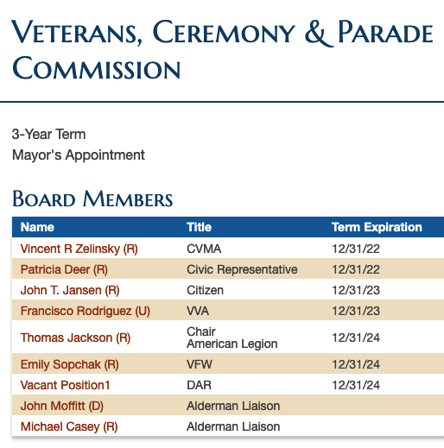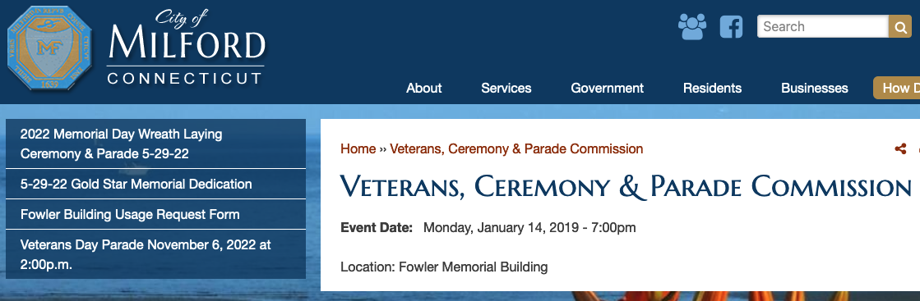
For the Good of the Order:
Any comments or questions? No comments or questions.

Meeting adjourned at 7:58pm
Respectfully submitted by Cathy (Gorman) Rose, Recording Secretary

